

**SOFTWARE QUALITY ENGINEERING**

**ASSIGNMENT #2 REPORT**

**BY:**

**MUHAMMAD AYAZ HASAN**

**20K-1044**

**SE-5A**

**JUNIT TESTING FOR FUNCTIONAL PROGRAM**

In this program i made a function “get_square” which return the square of the given input number

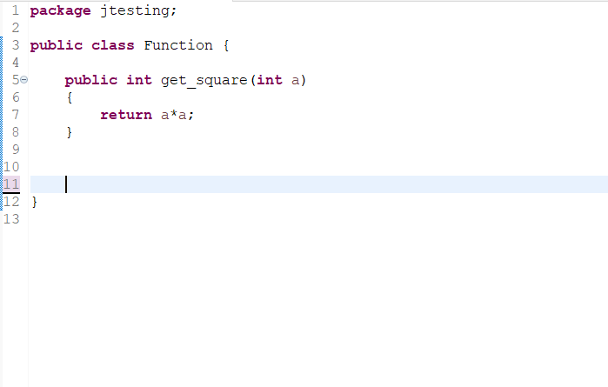

The below code performs junit testing for the above program.i pass the value “7” and then compare the expected result by using “assertEquals” function which compares the expected result with given input. The below test case run successfully.

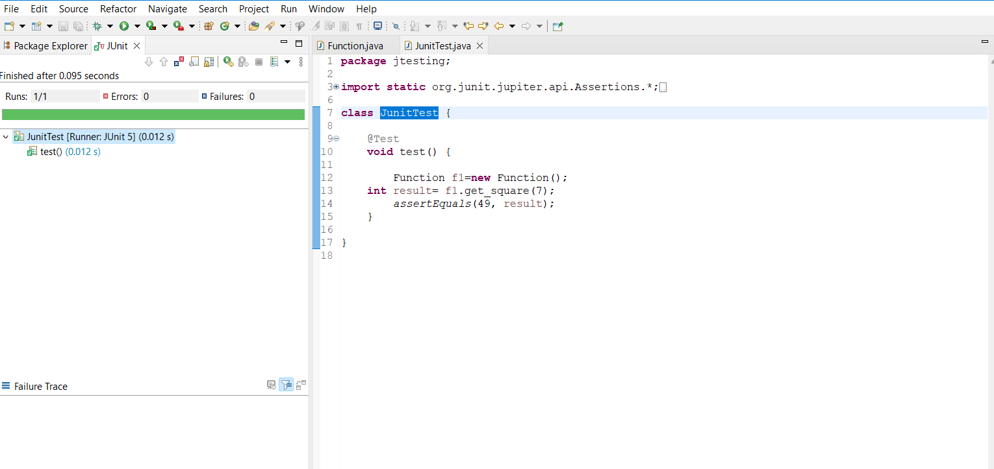

For Invalid value:

Here I change the expected value to “50” so after running this test case It shows the Failure.

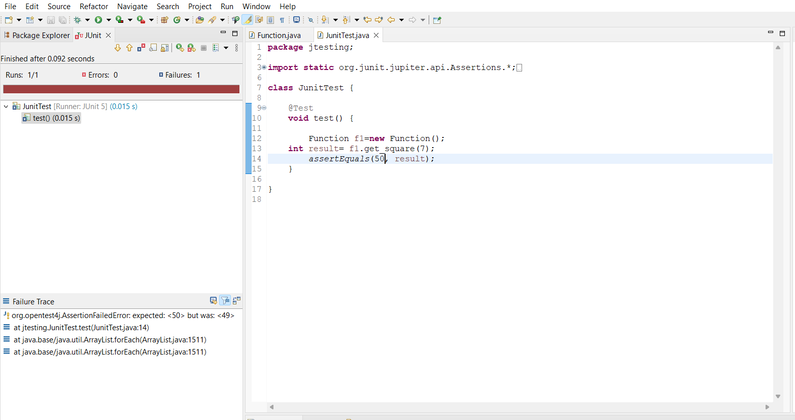

**JUNIT TESTING FOR CONDITIONAL PROGRAM**

This Program take the integer value and check the three conditions

1. If value>0 then add+10 in the value
2. If value <0 the subtract -10 in the value
3. If value =0 then add+100 in the value

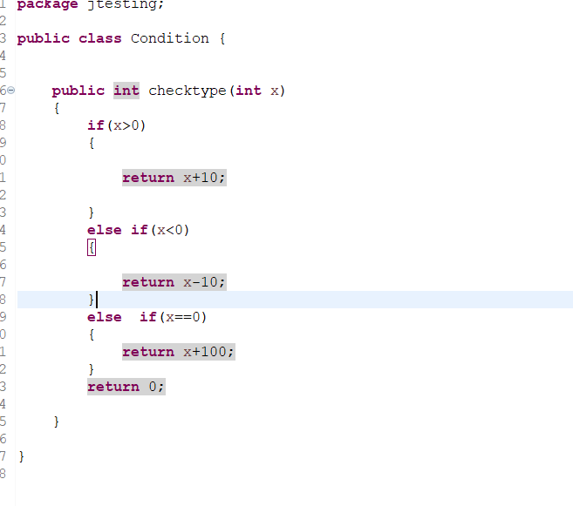

Junit Test Cases For the Above Code:

Valid expected +ve Value:

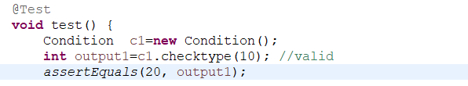

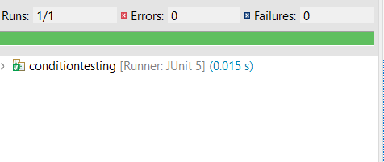

Invalid expected +ve Value:

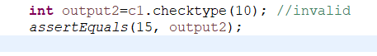

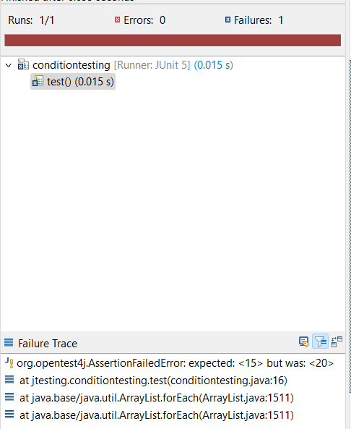

Valid expected -ve Value:

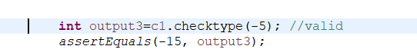 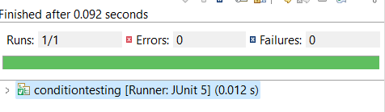

Invalid expected -ve Value:



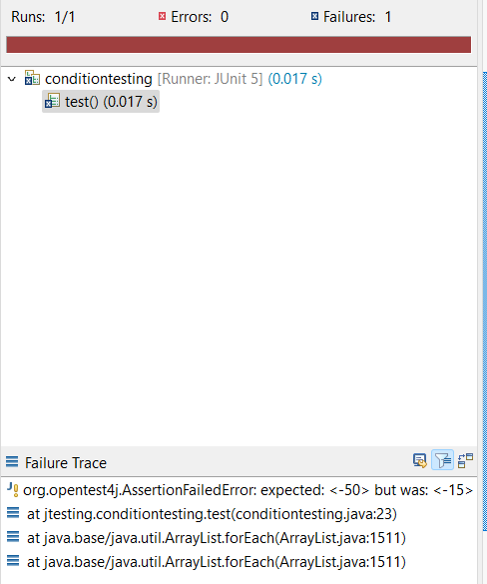

For Value=0:



